1. Introduction

This document summarises the collaboration of Group 2 for the programming and technology exam of the 3rd Semester. The group consists of 4 members of 4 different nationalities. In spite of the major differences in our opinions (we agreed on certain rules and guidelines to follow, thoroughly elaborated in the accompanying document called group contract), we managed to harness the benefits of diverse ideas and identify multiple possible approaches to certain problems.

The idea of the project is to create a service that handles multiple chatrooms with limited people count capacity where people can discuss topics they are passionate about which the users may access either via the web client or the windows application. Listening to music through the application using YouTube Data API and joining groups are other major user stories of our program.

Some of the problems we had to find the answer to include but are not limited to: Users whose number is greater than the available slots in a given chatroom try to join at the same time (for example, there is 1 slot left but 2 people try to join), a group whose number of people is greater than the available slots in a given chatroom tries to join (for example, a group of 4 attempts to join when there are only 3 or less slots left), preventing SQL Injection, learning how to use callbacks and bindings.

After formulating the problem statement and having it approved by the supervisors we were assigned the task of solving the problem by creating a web service, selecting the appropriate middleware and create both a dedicated and a web client.

2.1 Service Related

Designing and implementing a web service is the main goal of this project. Selecting the correct one is of great significance.

2.1.1. API   
For various reasons, which will be explained below, we have decided to use Representational State Transfer (REST) API for our web service.

a. Pros

REST is not bound to a single protocol, which allows for greater extensibility of our software. Also, REST has relatively low degree of coupling between the client and the service allowing better maintainability for our service. Lastly, REST is stateless – messages exchanged between the server and the client have all the necessary information for the message to be processed.

b. Cons

Having all this extra data in the messages can be considered redundant information (in the case where that some or all of this information is not used) which can have a small negative impact on latency. Additionally, having the business logic decoupled from the presentation can also add a tiny amount of latency

c. Other possible choices

Simple Object Access Protocol, which is not architecture but a protocol (as it can be seen from the name), if well implemented it could offer slightly better performance. However, the knowledge and experience required to use it properly are way higher increasing development cost. Not to mention that it increases coupling which will also increase maintenance costs and decrease the scalability of our application. That is why REST was the better choice, especially for agile development.

2.1.2 Framework  
a. Choice

For this project we created a web service to fulfil the needs of our users. Since our users may have devices running different type of operating systems (Windows, Android, iOS etc.). We have chosen Windows Communication Foundation Framework.

b. Pros

WCF can have multiple types of bindings including TCP (faster, binary data format, lower compatibility level) and HTTP (xml data format, higher compatibility level). Furthermore it offers great flexibility as it automatically selects the appropriate type of binding depending on what the user device is compatible with (as long as such type of a binding is configured).

c. Cons

WCF can be slower than an API that is designed to use only one type of binding, however, the difference so insignificant that it is not worth sacrificing the compatibility benefits.

d. Other possible choices

WebAPI is not a bad choice as it is easier to understand and learn, it is great for HTTP services. However, it is very limited in terms of compatibility compared to WCF.

2.3. Middleware  
2.3.1. Client to service.  
a. Choice  
For our dedicated client we are using ‘wsDualHttpBinding’ which allows both end points to send requests to each other independently with a duplex contract. This is best used in our chat system. For the purpose we needed to specify a callback contract in our service contract. For our MVC client we are using ‘wsDualHttpBinding’ and ‘wsHttpBinding’. The dual one we need to be able to use duplex contracts, while just the http one is used for messages that are only client-invoked.

b. Pros.  
The necessity of callbacks for our program, especially for the chat functionality is best solved by the ‘wsDualHttpBinding’ because it allows two-way message sending in text format over the internet provided that the duplex contract is used and it also has message security level.

c. Cons.  
Sending data in the xml format can cost more resources and reduce performance when compared to the binary format of IPC or TCP, for instance. However, http allows for greater compatibility and is required for communication between devices on the internet, whereas TCP is for intranet.

d. Other possible choices

Sending data in binary format such as TCP or IPC could have a positive impact on our performance. IPC is the fastest of all bindings but it only allows communication between two services on the same machine. TCP is also faster than the http bindings but it requires both the client and the service to have WCF and to be on the same network.

2.3.2 Service to database  
In order to access the SQL Server database we need a middleware to communicate between C# and SQL.

1. Choice

For the purpose we have chosen ADO.NET. It is a decent data access API and is fairly easy to use.

1. Pros

ADO.NET is readily supported by any .NET language. Also it is faster than some other API-s, for instance, Entity Framework.

1. Cons

On the other hand, ADO.NET requires bigger queries when compared to entity and has less encapsulation compared to Entity Framework.

1. Other possible choices

We were considering to switch to Entity Framework for better security, encapsulation and to cut down on redundant code. However, Entity Framework was not designed to be flexible in terms of database model changes which can happen quite often when doing agile development.

2.4 Security

2.4.1 Password storage

This is the first step we took towards security measures in our project. The last thing we want is if someone manages to compromise the database to be able to obtain the passwords of the unsuspecting users. What we did was to add ‘salt’ (a unique random string) to the password and then hash it before storing it in the database. This ensures that even if someone manages to see all the values in the database they will not be able to make much use of it as the password is hashed. And because of the salt two same passwords will still have different hash values making it even harder to crack. Of course we have to store the salt in the database because it is added to the password every time before it is hashed and checked against the password hash stored.

2.4.2 SQL Injection

SQL Injection is a very wide-spread way of executing malicious code on a database. It occurs when a user enters data in such a way that it executes SQL commands that are not supposed to be executed. The following examples are taken from <https://www.w3schools.com/sql/sql_injection.asp>.

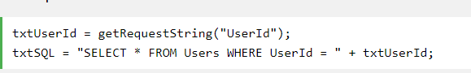

In this case you can cause SQL injection by making a statement always true if the user inputs this for example:



This will execute a statement which looks like this:



That would be a big problem if that table contains some sensitive information like passwords for instance. The user could enter any command after the id in that textbox. They could drop a table and destroy the database which will probably destroy the program’s functionality.

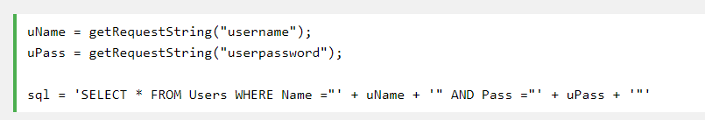

A statement like this can be bypassed by simply entering the following input:

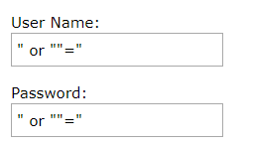

What will be actually executed is this:



It will select all rows from the users table since the condition after ‘or’ is always true.

Here is an example how we protect our database against SQL injection:

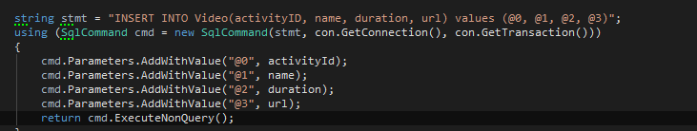

Declaring an SQL command that takes only parameters rather than strings prevents users with bad intentions of executing any code that they should not. Not only is this safer, but it also makes the program more robust by returning an integer of how many rows were affected by this statement. In this way we can easily check if the statement was successfully executed. And if that weren’t enough, it makes the code way more readable and easier to write instead of having a large number of concatenated strings.

2.4.3 DDOS Protection

In due course.

2.6 Performance

Here we have measured the time it takes for certain methods to be executed completely. The tests were conducted using the “System.Diagnostics.Stopwatch” class by starting the timer at the beginning of a button click and printing the result as soon as the action was completed.

The time it took to login with up to 16 online users by sending a login request every second:

Average: 367ms, Best: 335ms, Worst: 407ms.

As you can see the results are very close to each other and the differences can be accounted to outside factors such as current load of the network it goes through, background OS process etc. Compared to the time it took to join a chatroom as a group of 20 users simultaneously which was 454 milliseconds, we can conclude that there is barely any decay in performance.